
Village of Springville & Town of Concord present

THURSDAYNIGHT

summer concertseries

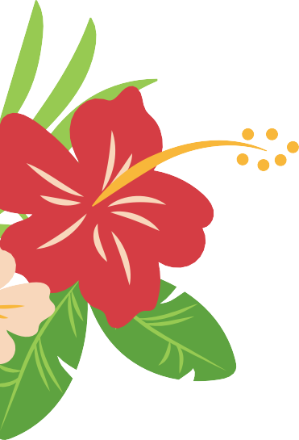
Heritage Park Gazebo behind 65 Franklin St Springville
JUNE 25 - AUG 20, 2026
6:30 pm - 8:30 pm

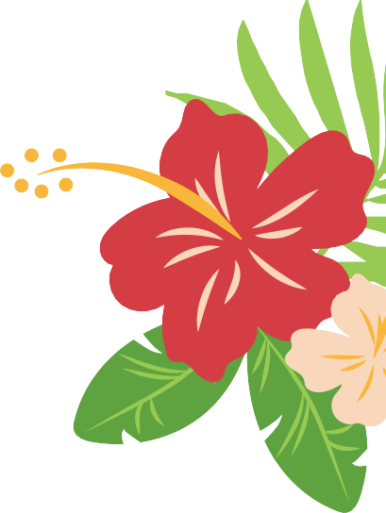
BANDS ARE IN ORDER OF APPEARANCE
- Bill Cocca’s Silver Band June 25
- Invisible Touch July 3
- Hintz of Thunder (New Band) July 9
- Flipside July 16
- Something Scarlet (New Band) July 23
- RedSky Night (New Band) July 30
- Barnstorm Aug 6
- Midnight Recovery Band Aug 13
- Kody and Herren (New Band) Aug 20
- Springville Jazz Orchestra Aug 27

Hot dogs & snacks by Kiwanis & Southtowns Bark Park

July 3rd Concert by Invisible Touch from 7-9:30pm at the Concord Town Park on N. Buffalo. Fireworks following
The Concert.

