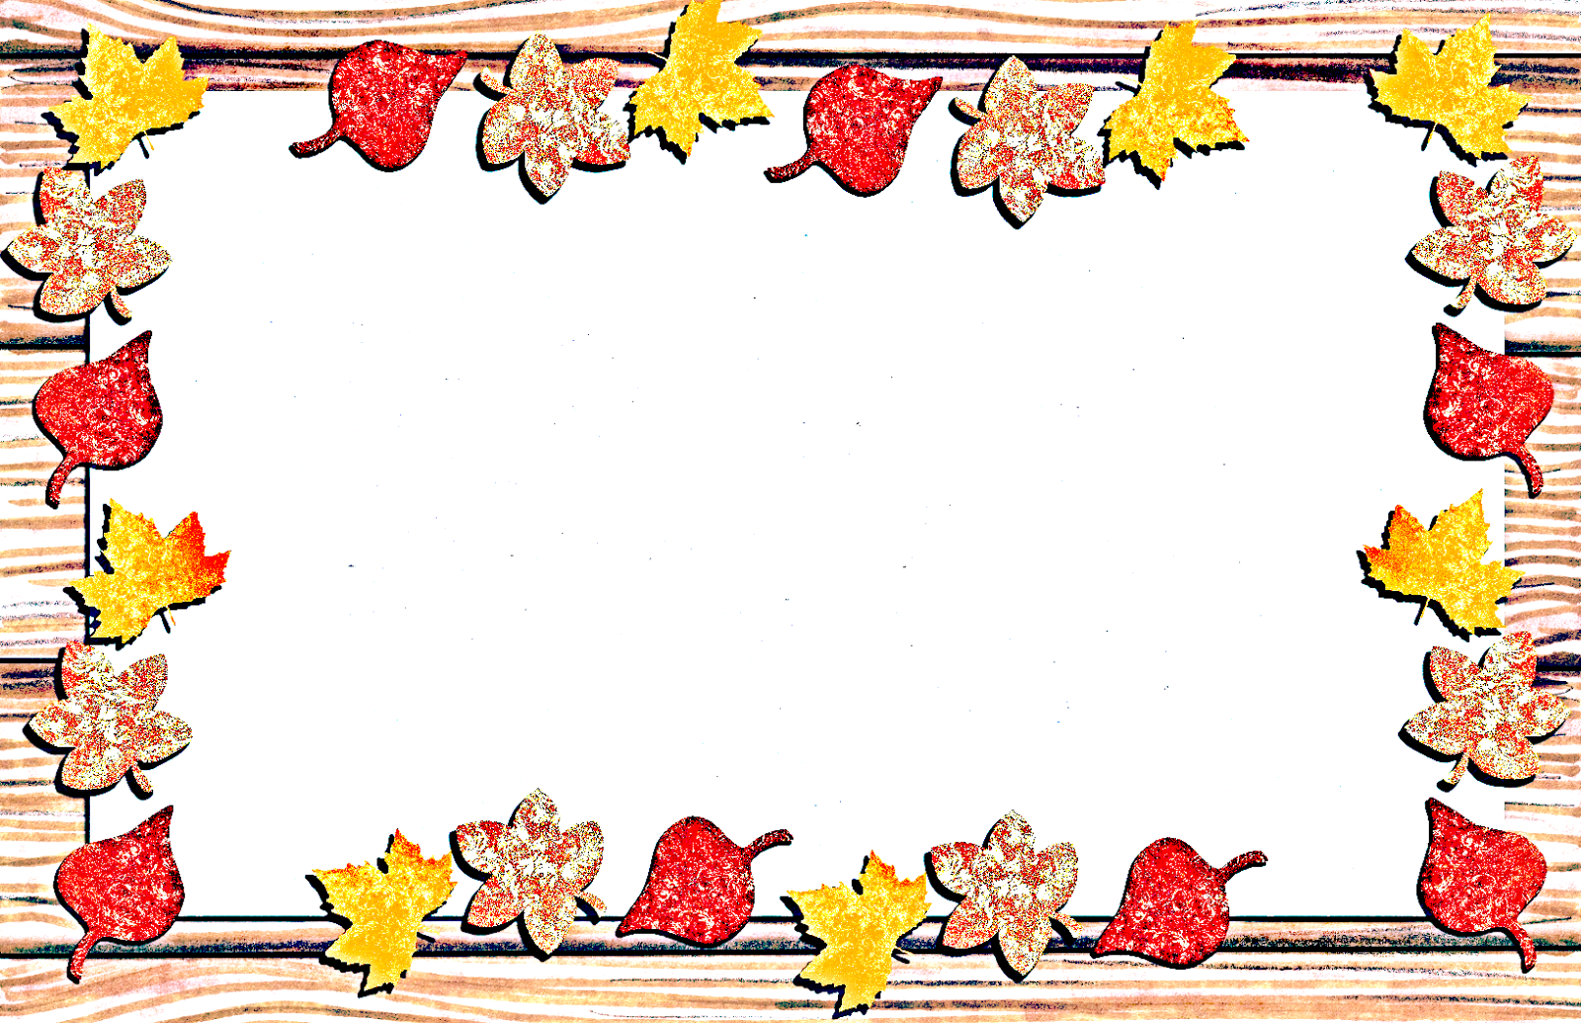
The Village Office will be closed on Thursday and Friday, November 27th & 28th due to the Thanksgiving holiday.

The Village of Springville staff would like to wish everyone a safe and happy holiday season.

